At-Risk Populations in the Gulf of Mexico:
Kemp’s Ridley Sea Turtle and the Bottlenose Dolphin

- Kemp’s Ridley Sea Turtle
Introduction

Even before the Deepwater Horizon oil spill in the Gulf of Mexico in 2010, the Kemp’s ridley sea turtle was already highly endangered.¹ Of course, the spill did not help. While these turtles are highly migratory, the Gulf of Mexico is one of their favorite habitats.¹ In the summer, female sea turtles return to the beaches where they were hatched to lay their eggs.¹ Females lay eggs every one to three years after the age of 10–12.¹ Turtles lay their eggs on the beach, not in water, so when the young turtles hatch, they must make their way from the beach down to the water. Even in the best of circumstances, there are many predators and many turtles do not make it.¹ The 2010 oil spill in the Gulf not only affected adult turtles, but it also greatly exacerbated the dangers of hatching. Because exposure to oil is often fatal to sea turtles, young turtles that encountered oil on the beach or in the water would have been in great danger.² Environmental groups were able to relocate many sea turtle eggs to other beaches, but many eggs remained in the area of the oil spill.²

What are the long-term effects of the oil spill on Kemp’s ridley sea turtle populations?

On the left is a typical graph for the survivorship curve of a Kemp’s ridley sea turtle, and on the right is what it might look like for the cohort born during the Gulf spill.
Question 1. Please sketch the curve for the graph on the right.
Sea Turtle Survivorship Curve—Born Before Spill Sea Turtle Survivorship Curve—Born During Spill
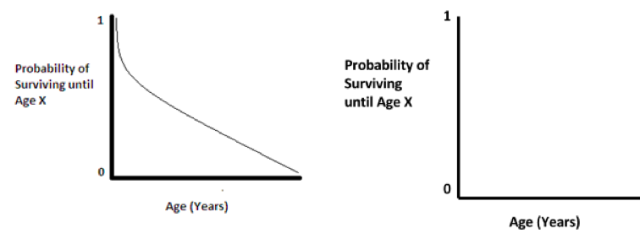

Question 2. Briefly analyze your graph. Which part shows the effect of the oil spill on this cohort? Define “cohort” in your own words.
The X-Axis shows the effects of the oil spill on this cohort and shows the lesser surviving young. The death rate is higher in the young after the spill vs before the spill.

Cohort: is the set or group of a population or species born at the same time.

To help analyze what this means for the future of the Kemp’s ridley sea turtle, we have constructed an age pyramid. On the left is a typical age pyramid for Kemp’s ridley sea turtles, and on the right is what it might look like in 2016.
Question 3: Please fill in the rest of the pyramid on the right.

Sea Turtle—Age Pyramid Before Spill Sea Turtle—Projected Age Pyramid (2016)

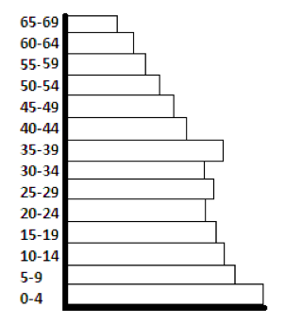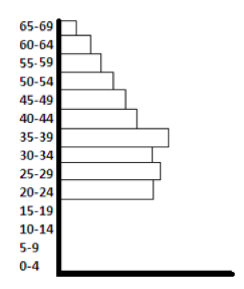
Question 4. Briefly analyze the age pyramid. What features show the effect of the Gulf oil spill? How are young turtles (0–19) affected in particular? Predict what this might mean for the future of Kemp’s ridley sea turtles.
There was a population decrease of young turtles because not many were hatched. There was also a high mortality rate. The number of turtles that survived till the age 45-69 were even more fewer than before the spill.
Young turtles between ages 0-19 were phased out since none were hatched according to the graph.
This means that in the future, there is a chance that Kemp’s ridley turtles will be extinct as the young ones age and die.

Question 5. Was the oil spill a density-dependent or a density-independent factor for the sea turtles? Briefly explain.
The density-independent Factor is one that will effect a population the same whether the population is big or small such as the BP oil spill.

- Bottlenose Dolphins
Introduction

Bottlenose dolphins spend much of their time far out to sea, and thus were less likely to come into direct contact with the oil spill. However, dolphins are mammals and must surface to breathe, which brought many dolphins into direct, and often fatal, contact with oil.² Another problem for bottlenose dolphins was food scarcity and contaminated prey.⁴ Dolphins are carnivores, feeding primarily on fish, shrimp, and squid.³ The oil from the spill contaminated the dolphins’ food source and caused drops in the numbers of animals they could eat.

How have these two risks affected the dolphin population?

Bottlenose dolphins are thus facing two different risks from the oil spill: coming into contact with oil through surfacing and food scarcity. Both of these risks will have the effect of limiting the population size.

Question 6. Is the first risk—direct contact with oil—an example of a density-independent or density-dependent regulating factor? Explain.
Density-independent, because oil spill is a density independent factor. (Tiger, 1996, p.1)
Direct contact with oil is density-independent because contact with oil is deadly no matter how many turtles there are in the population

Food scarcity, the second risk, affected the number of dolphins the Gulf of Mexico can support. This number is called carrying capacity. If the population of dolphins was well below the carrying capacity before the spill, the population would have been increasing.

Question 10. Describe the effect of the lowered carrying capacity on the growth of the dolphin population. Is the population likely to be increasing, decreasing or steady? Why?
Decreasing due to the impact of oil spills puts a stress on the food resource by putting the Animals at risks with the food chain. This makes prey scares during breeding season. This also makes dolphins weakened by depleted food resources, bacteria and other factors as a result of oil spills.
(National Wildlife, 1996, p.1)

Question 11. Is this an example of a density-dependent or density-independent regulating factor? Explain.
It is a density independent regulating factor since the record dolphin die off was already on the decline and will continue declining regardless of the death of their source of food.

References
- http://animals.nationalgeographic.co.uk/animals/reptiles/kemps-ridley-sea-turtle/
- http://www.nwf.org/What-We-Do/Protect-Habitat/Gulf-Restoration/Oil-Spill/
Effects-on-Wildlife/Sea-Turtles.aspx
- http://animals.nationalgeographic.com/animals/mammals/bottlenose-dolphin/
?source=A-to-Z
- http://www.livescience.com/21730-dolphin-deaths-bp-oil-spill.html

Note: The effects of the oil spill on these two species are real, but the data are hypothetical.

